6.22赤潮发生预测

The forecast of potentially-toxic algal blooms reproduction

我们收集巢湖相关的数据共129组，对数据进行分配，其中91组作为训练数据，19组作为验证数据，19组作为测试数据，训练18代后结果收敛，得到的训练效果曲线如下：

We collect relevant data about Chao Hu from 129 groups, which are assigned subsequently, and 91 groups are used as train data, 19 groups as **validation data and 19 groups as train data,** The [results](http://cn.bing.com/dict/clientsearch?mkt=zh-CN&setLang=zh&form=BDVEHC&ClientVer=BDDTV3.5.0.4311&q=%E7%BB%93%E6%9E%9C%E6%94%B6%E6%95%9B" \t "_blank) [converge](http://cn.bing.com/dict/clientsearch?mkt=zh-CN&setLang=zh&form=BDVEHC&ClientVer=BDDTV3.5.0.4311&q=%E7%BB%93%E6%9E%9C%E6%94%B6%E6%95%9B" \t "_blank) [reasonably](http://cn.bing.com/dict/clientsearch?mkt=zh-CN&setLang=zh&form=BDVEHC&ClientVer=BDDTV3.5.0.4311&q=%E7%BB%93%E6%9E%9C%E6%94%B6%E6%95%9B" \t "_blank) [well](http://cn.bing.com/dict/clientsearch?mkt=zh-CN&setLang=zh&form=BDVEHC&ClientVer=BDDTV3.5.0.4311&q=%E7%BB%93%E6%9E%9C%E6%94%B6%E6%95%9B" \t "_blank) when data are trained at the 18 generation and the effects of curve is shown as follows;

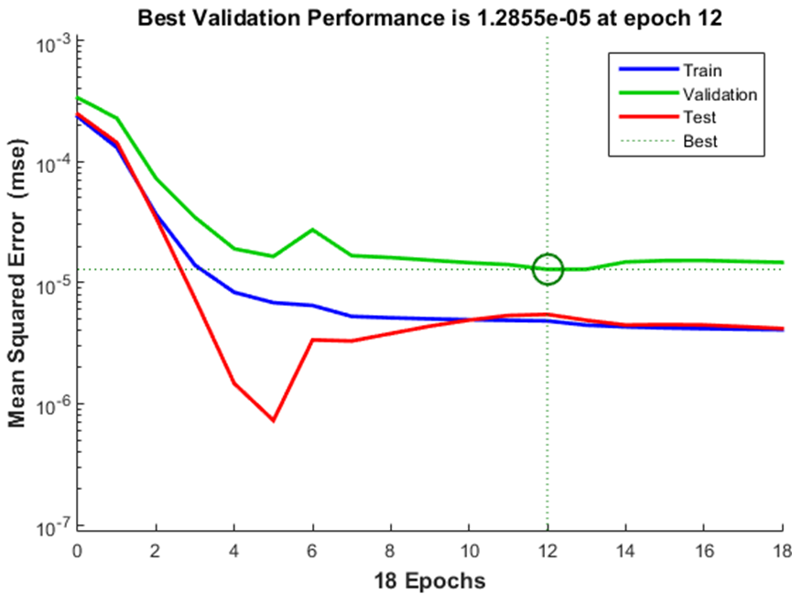

相关系数曲线如下：

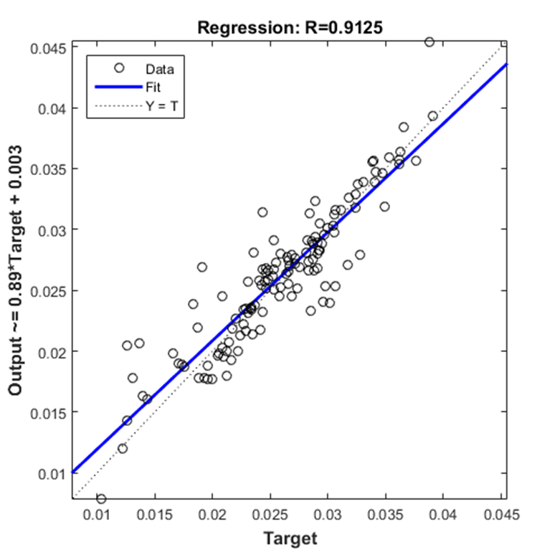

结果分析：最终训练出来的模型与实际数据相关性达到了91%，说明神经网络拟合效果很好，符合我们对N,P含量对叶绿素a含量影响的预期表现.

Analysis result, the correlation between the model trained with data and real data is up to 91%,reflecting that [BP](http://cn.bing.com/dict/clientsearch?mkt=zh-CN&setLang=zh&form=BDVEHC&ClientVer=BDDTV3.5.0.4311&q=%E7%A5%9E%E7%BB%8F%E7%BD%91%E7%BB%9C%E9%A2%84%E6%B5%8B" \t "_blank) [neutral](http://cn.bing.com/dict/clientsearch?mkt=zh-CN&setLang=zh&form=BDVEHC&ClientVer=BDDTV3.5.0.4311&q=%E7%A5%9E%E7%BB%8F%E7%BD%91%E7%BB%9C%E9%A2%84%E6%B5%8B" \t "_blank) [network](http://cn.bing.com/dict/clientsearch?mkt=zh-CN&setLang=zh&form=BDVEHC&ClientVer=BDDTV3.5.0.4311&q=%E7%A5%9E%E7%BB%8F%E7%BD%91%E7%BB%9C%E9%A2%84%E6%B5%8B" \t "_blank) [method](http://cn.bing.com/dict/clientsearch?mkt=zh-CN&setLang=zh&form=BDVEHC&ClientVer=BDDTV3.5.0.4311&q=%E7%A5%9E%E7%BB%8F%E7%BD%91%E7%BB%9C%E9%A2%84%E6%B5%8B" \t "_blank) is [feasible](http://cn.bing.com/dict/clientsearch?mkt=zh-CN&setLang=zh&form=BDVEHC&ClientVer=BDDTV3.5.0.4311&q=%E7%A5%9E%E7%BB%8F%E7%BD%91%E7%BB%9C%E9%A2%84%E6%B5%8B) to [predict](http://cn.bing.com/dict/clientsearch?mkt=zh-CN&setLang=zh&form=BDVEHC&ClientVer=BDDTV3.5.0.4311&q=%E7%A5%9E%E7%BB%8F%E7%BD%91%E7%BB%9C%E9%A2%84%E6%B5%8B" \t "_blank) [.](http://cn.bing.com/dict/clientsearch?mkt=zh-CN&setLang=zh&form=BDVEHC&ClientVer=BDDTV3.5.0.4311&q=%E7%A5%9E%E7%BB%8F%E7%BD%91%E7%BB%9C%E9%A2%84%E6%B5%8B" \t "_blank)the N,P concentrations have a great impact on the [quantity](http://cn.bing.com/dict/clientsearch?mkt=zh-CN&setLang=zh&form=BDVEHC&ClientVer=BDDTV3.5.0.4311&q=%E5%8F%B6%E7%BB%BF%E7%B4%A0a%E5%90%AB%E9%87%8F" \t "_blank) of [chlorophyll](http://cn.bing.com/dict/clientsearch?mkt=zh-CN&setLang=zh&form=BDVEHC&ClientVer=BDDTV3.5.0.4311&q=%E5%8F%B6%E7%BB%BF%E7%B4%A0a%E5%90%AB%E9%87%8F" \t "_blank) [a](http://cn.bing.com/dict/clientsearch?mkt=zh-CN&setLang=zh&form=BDVEHC&ClientVer=BDDTV3.5.0.4311&q=%E5%8F%B6%E7%BB%BF%E7%B4%A0a%E5%90%AB%E9%87%8F" \t "_blank) and getting a better outcome.

也就是说，N,P含量之间影响到了水中藻类的生长,经过统计与预测，当N含量大于2.5mg/L,P含量大于0.3mg/L时便可能使叶绿素a超标,产生水华，并且在实际水藻的生长环境允许范围内，叶绿素a含量随着N，P含量的增长而增长,也就意味着水中藻类数量在增加。

That’s to say, the growth of potentially-toxic algal blooms in water is affected by N,P nutrient load, by [statistics](http://cn.bing.com/dict/clientsearch?mkt=zh-CN&setLang=zh&form=BDVEHC&ClientVer=BDDTV3.5.0.4311&q=%E7%BB%9F%E8%AE%A1%E4%B8%8E%E9%A2%84%E6%B5%8B) [analysis](http://cn.bing.com/dict/clientsearch?mkt=zh-CN&setLang=zh&form=BDVEHC&ClientVer=BDDTV3.5.0.4311&q=%E7%BB%9F%E8%AE%A1%E4%B8%8E%E9%A2%84%E6%B5%8B" \t "_blank) [and](http://cn.bing.com/dict/clientsearch?mkt=zh-CN&setLang=zh&form=BDVEHC&ClientVer=BDDTV3.5.0.4311&q=%E7%BB%9F%E8%AE%A1%E4%B8%8E%E9%A2%84%E6%B5%8B" \t "_blank) [prediction](http://cn.bing.com/dict/clientsearch?mkt=zh-CN&setLang=zh&form=BDVEHC&ClientVer=BDDTV3.5.0.4311&q=%E7%BB%9F%E8%AE%A1%E4%B8%8E%E9%A2%84%E6%B5%8B" \t "_blank), potentially-toxic algal blooms will reproduce in water when [nitrogen](http://cn.bing.com/dict/clientsearch?mkt=zh-CN&setLang=zh&form=BDVEHC&ClientVer=BDDTV3.5.0.4311&q=%E6%B0%AE%E5%90%AB%E9%87%8F" \t "_blank) content exceed 2.5mg/L and [nitrogen](http://cn.bing.com/dict/clientsearch?mkt=zh-CN&setLang=zh&form=BDVEHC&ClientVer=BDDTV3.5.0.4311&q=%E6%B0%AE%E5%90%AB%E9%87%8F) content is bigger than 0.3mol/L, furthermore, [chlorophyll](http://cn.bing.com/dict/clientsearch?mkt=zh-CN&setLang=zh&form=BDVEHC&ClientVer=BDDTV3.5.0.4311&q=%E5%8F%B6%E7%BB%BF%E7%B4%A0a%E5%90%AB%E9%87%8F) [a](http://cn.bing.com/dict/clientsearch?mkt=zh-CN&setLang=zh&form=BDVEHC&ClientVer=BDDTV3.5.0.4311&q=%E5%8F%B6%E7%BB%BF%E7%B4%A0a%E5%90%AB%E9%87%8F) content will increase with increasing N,P nutrient load.